1. Open the Volume Controls by double clicking on the Volume icon in the lower right system tray. Go to Options and select Properties.

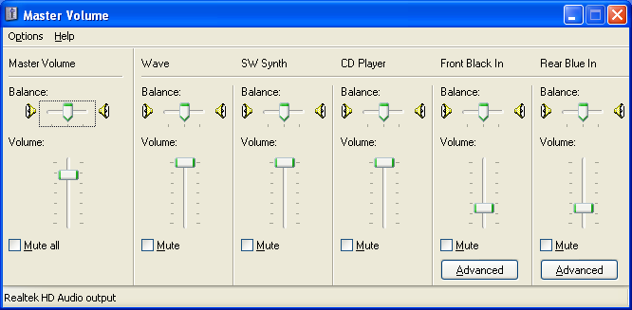

2. In the Mixer device, select the audio output. Make SURE all the boxes are checked. Select OK.

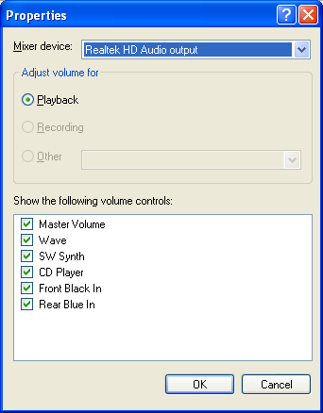

3. In the Mixer device, select the audio input. Make SURE all the boxes are checked. Select OK.
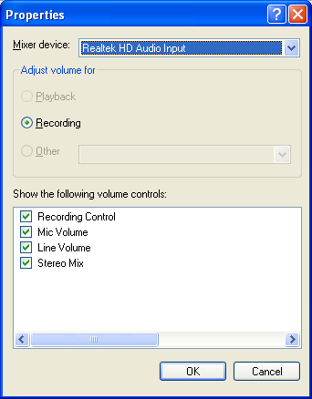

4. Make SURE all the Master Volume boxes are not muted and the volume is up at least ½ way.
These additional screen shots were added for newer computers (September 2012):

